In the realm of high-throughput genomics, efficient data acquisition is crucial for streamlined analysis and research. To facilitate the bulk acquisition of sequencing data, this protocol outlines a systematic approach for utilizing the database of National Center Biotechnology Information (NCBI) and the associated SRA-Explorer, both are simple yet robust platform designed for accessing genomic datasets and associated information. Specifically, this guide focuses on leveraging NCBI database to obtain information regarding biosample and sequence read archive (SRA) library and SRA-Explorer to batch download FASTQ files, ensuring a seamless and organized retrieval process. By following these instructions, researchers can optimize their workflow, minimize coding, and focus on the analysis of their genomic data.

**How to utilize NCBI**

Open Web Browser

Go to: <https://www.ncbi.nlm.nih.gov>

* Enter Project ID in NCBI search bar
* To the left of the search bar, select “BioProject”
* 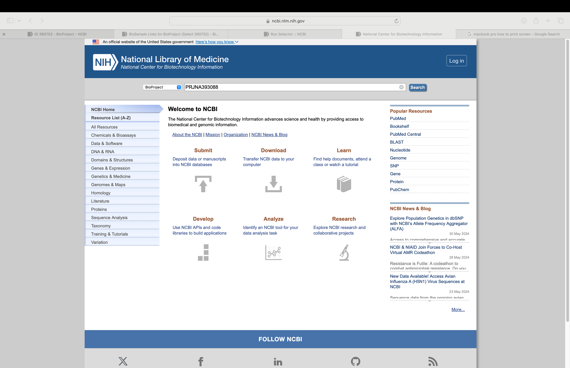Click search



**Download BioSample & SRA (Metadata, Accession List)**

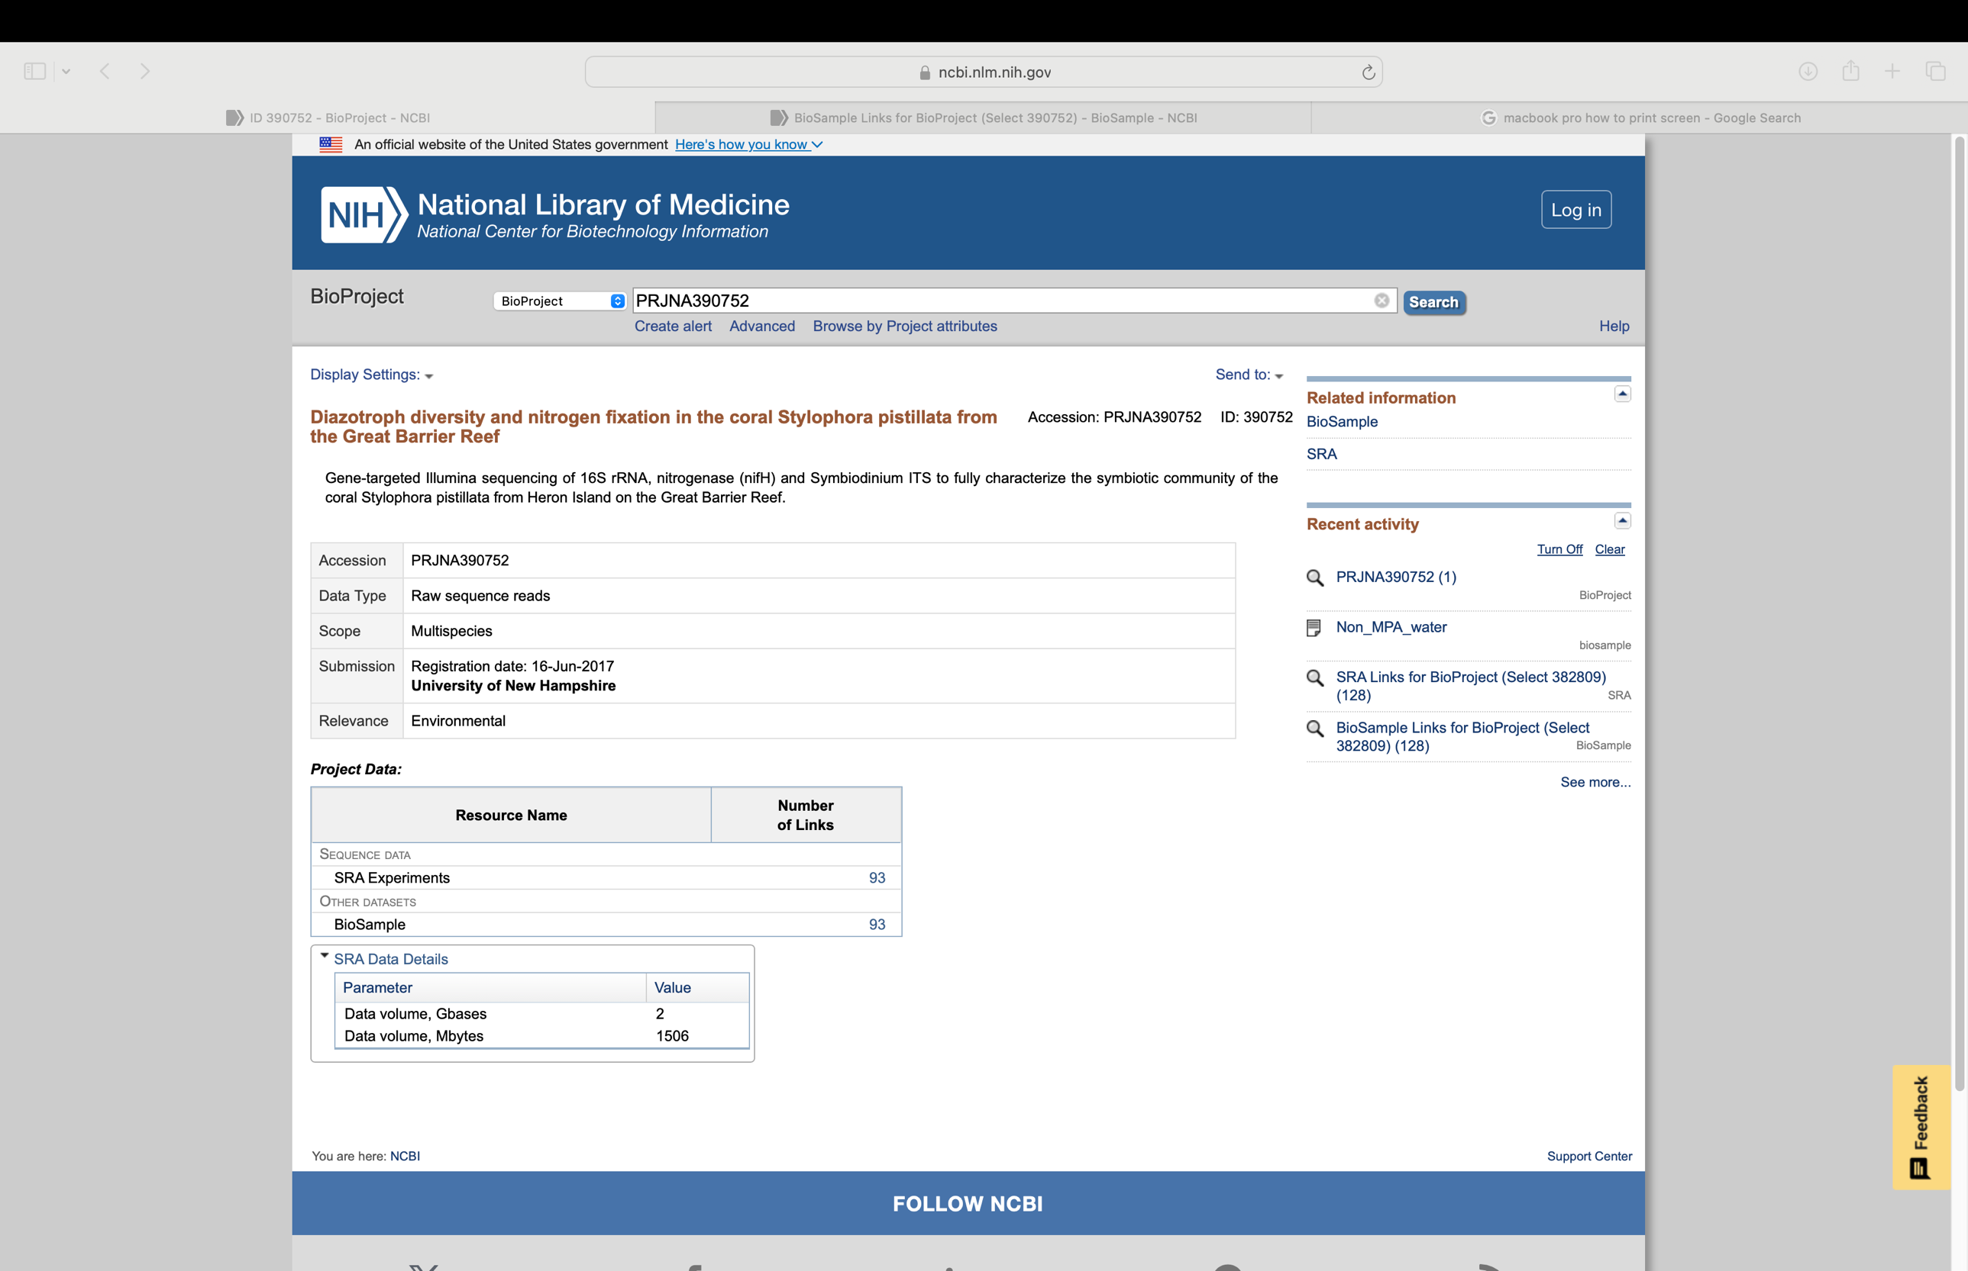



**Download BioSample**

* Under Related “BioSample” link
* To download all the associated BioSample links
  + Click “Send to:” drop down link/menu
  + Select File
  + Format: “Full Text”
  + Sort by: Default Order
  + 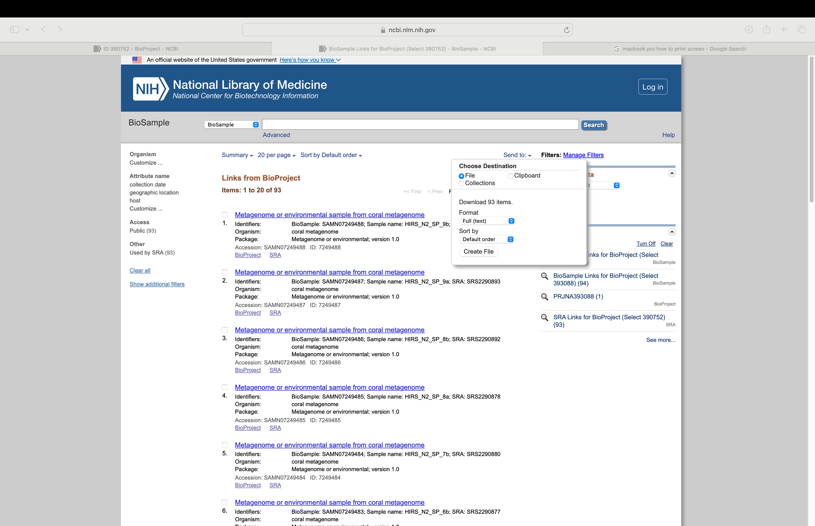Click create file



Download SRA

* Under Related Information, click “SRA” link
* To download all the associated SRR IDs
  + Select, at the top, “Send results to Run Selector”

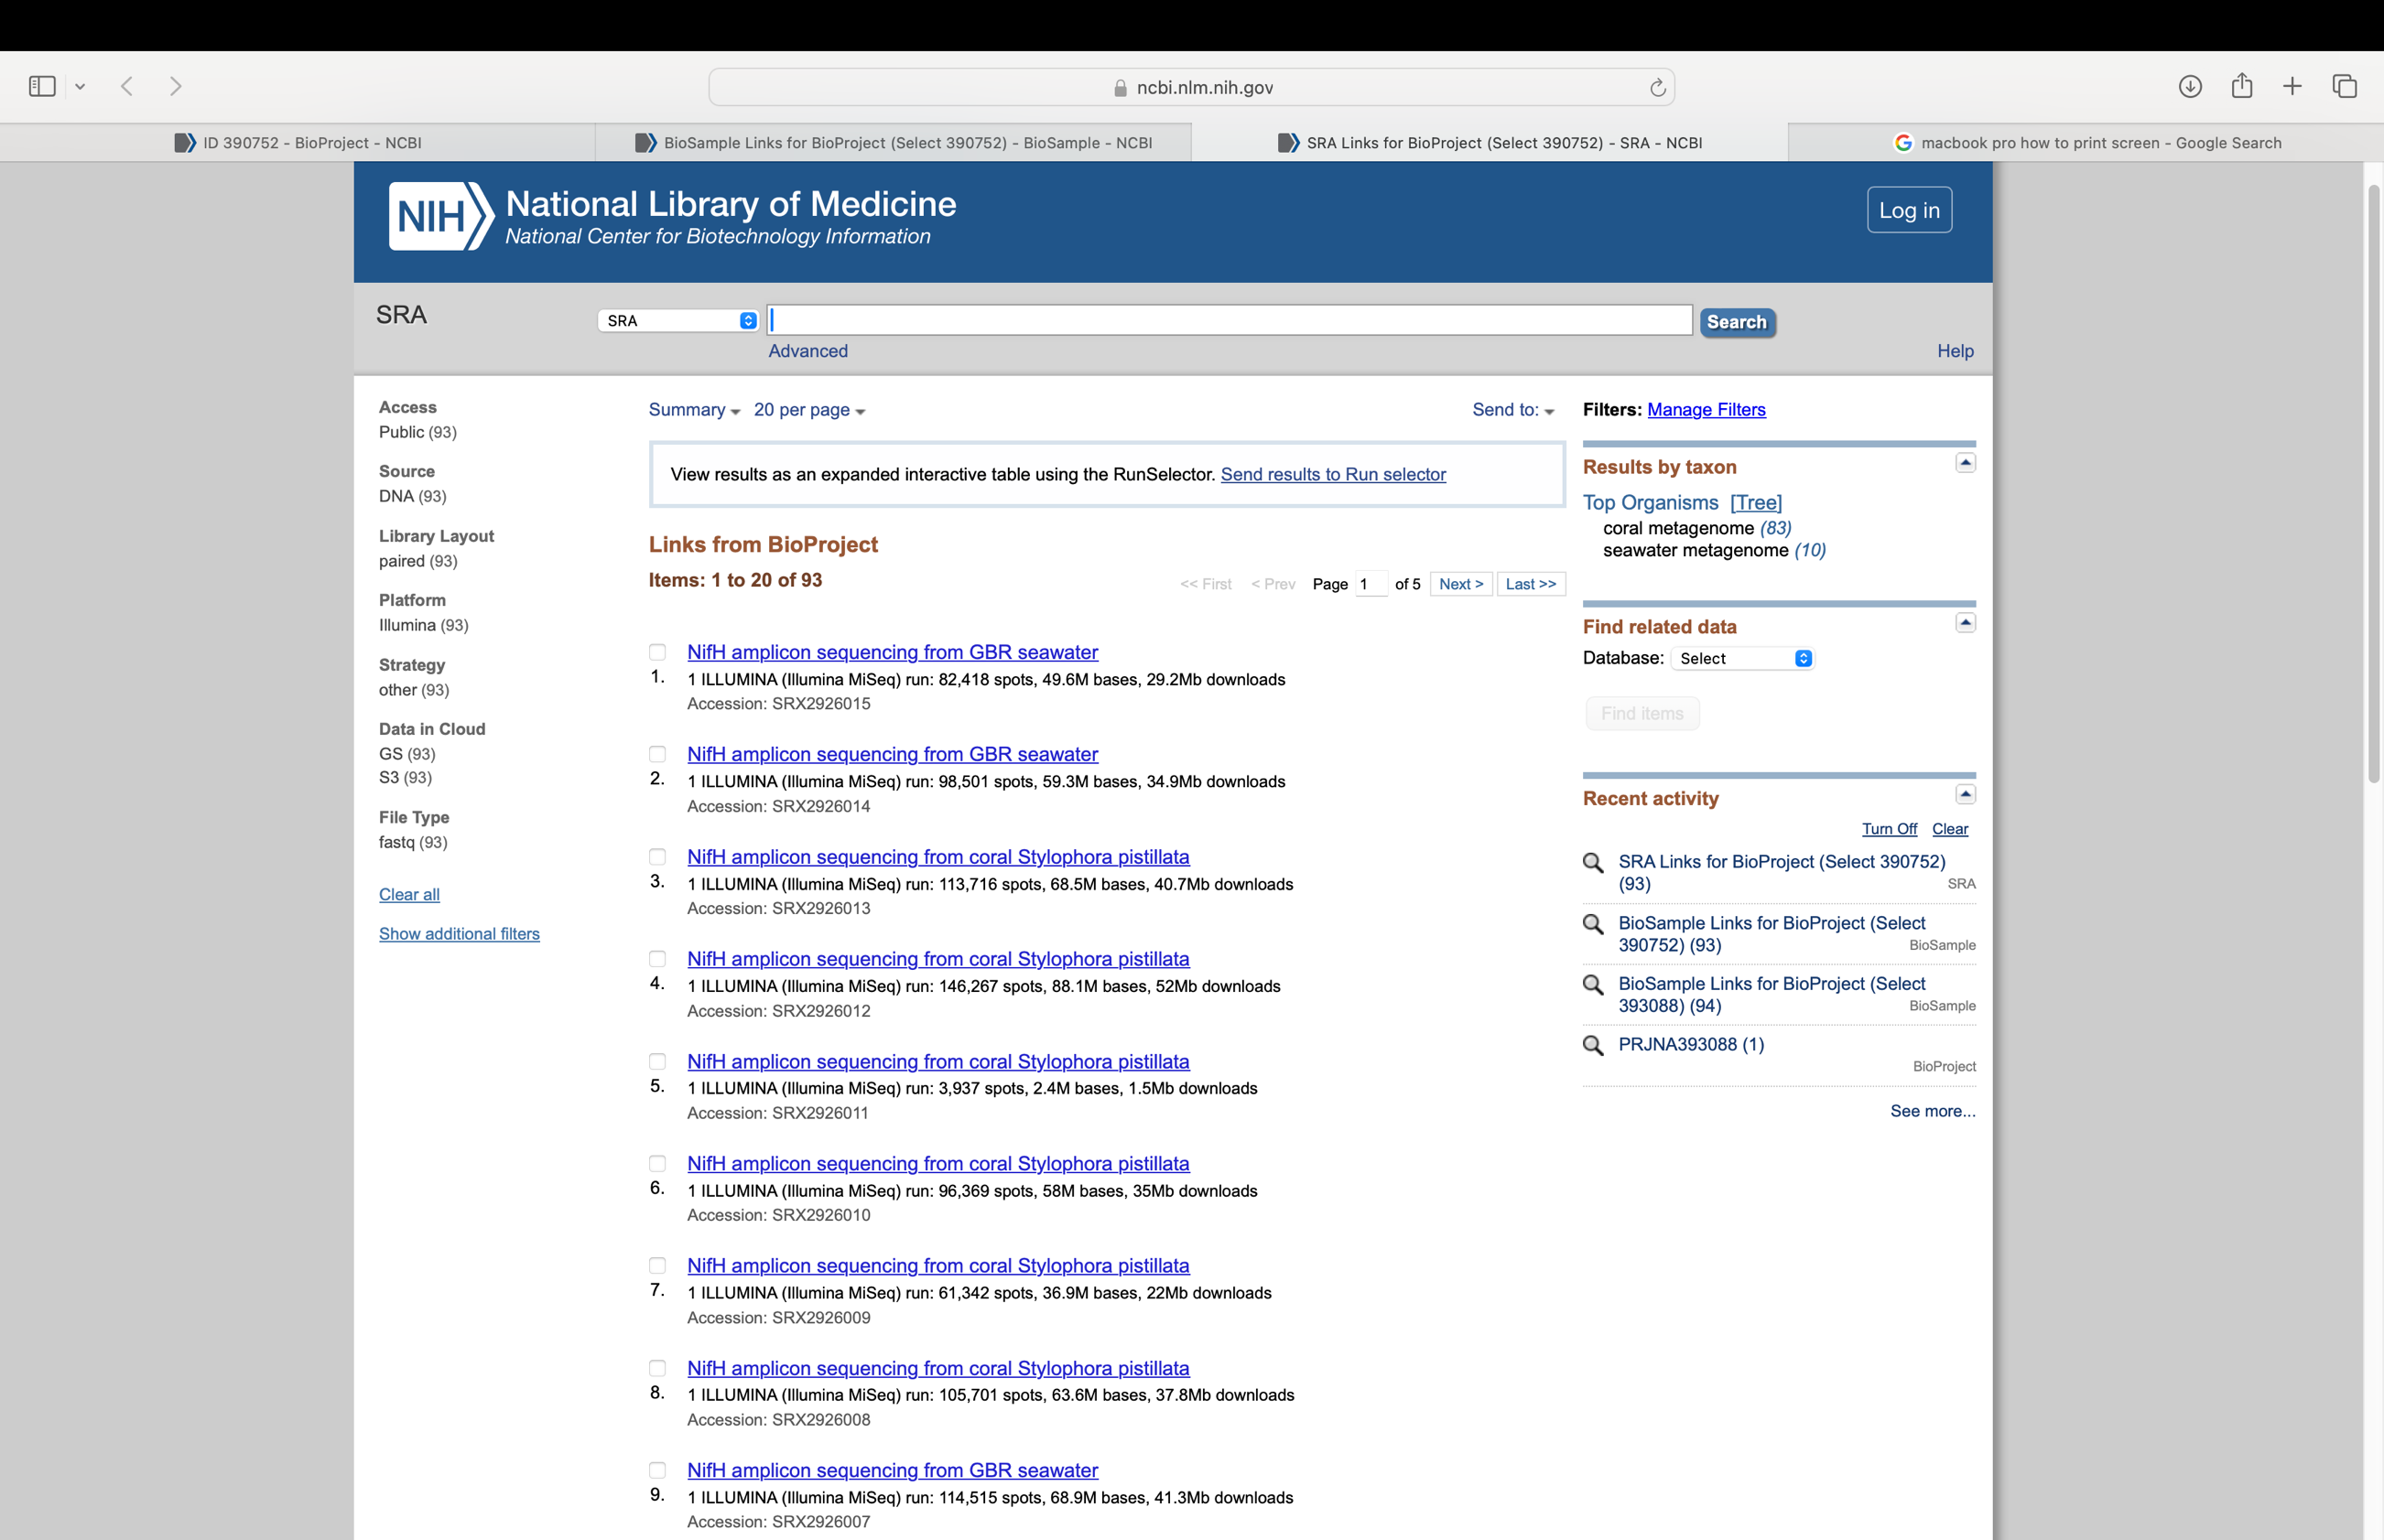



* + To Select all or individual Runs, click “check mark” under “Found”
  + Under Select section
    - Enable toggle for “Selected”
    - For Metadata download
      * Click grey bar “Metadata”
    - For Accession List
      * Click grey bar “Accession List”



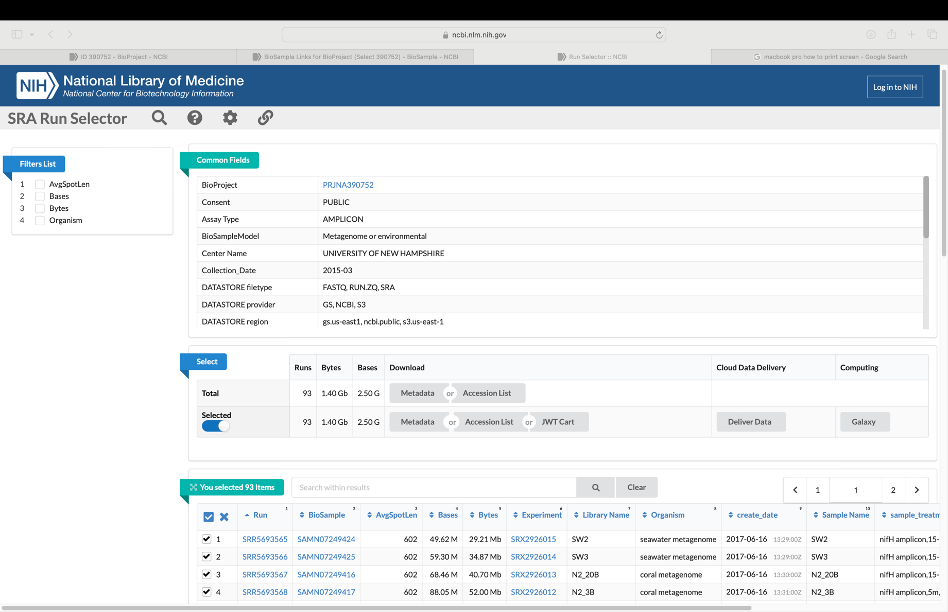

Downloading the accession list and metadata is useful to determine viable data and SRR ID or ERR ID to use for your particular research as well as when using the SRA-Explorermto downlowd the necessary FastQ files. The acessionlist provides a list of SRR IDs and ERR IDs, while the metadata provides the information associated with the biosamples, SRR IDs, and ERR IDs.

**SRA Explorer**

**Downloading Fastq Files**

To download the fastq files for the corresponding BioProject, SRR ID, or ERR ID, go to the website sra-explorer.info.

On the homepage, the search bar and parameters are there to search the Sequence Reads Archive (SRA).

Under the “SRA Explorer” header, in the “Search for” bar, enter the BioProject ID, SRR ID, or ERR ID

* For “Max Results”
  + Enter 500
* For “Start At Record”
  + Leave at “0”
  + Change when there are more than 500 SRR or ERR IDs
    - Enter the number 501 to continue the search for remaining results if larger than 500
* 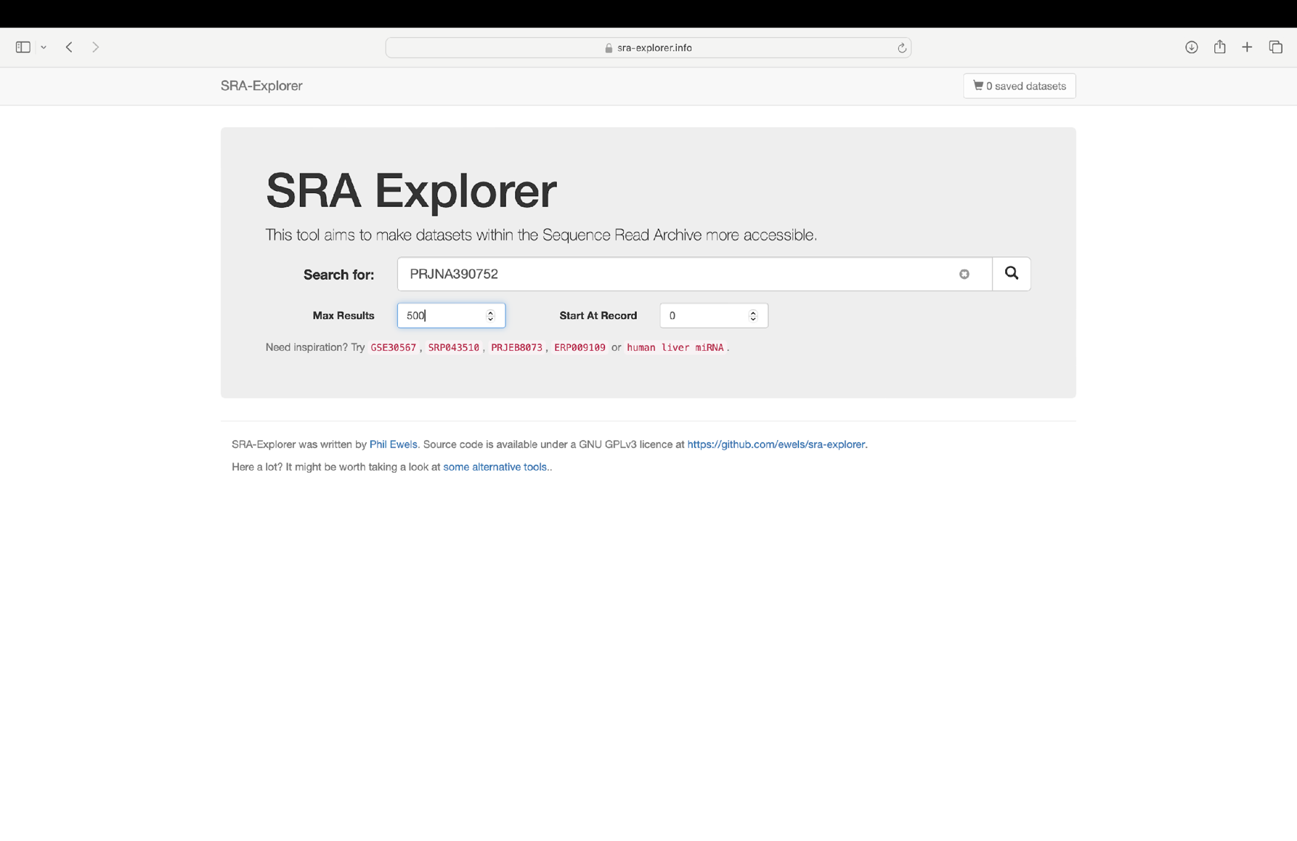Click the search icon or press enter



***SRA Explorer: Search Results***

The search results will be shown below the SRA Explorer search tool:

Under the blue banner, the number of results will be shown.

Under the number of results shown there is an input bar to filter the results for specificity associated with a particular research.

To select all of the results:

* Check the box next to “Title”. This will select all of the results that are unfiltered, or the results after filtering.
* Click the blue button “Add to collection” to place the results to the shopping cart.
* Then click the shopping cart at the top right corner of the webpage. The shopping cart button will turn blue and will show the amount of datasets saved, after clicking the blue “Add to Collection”.

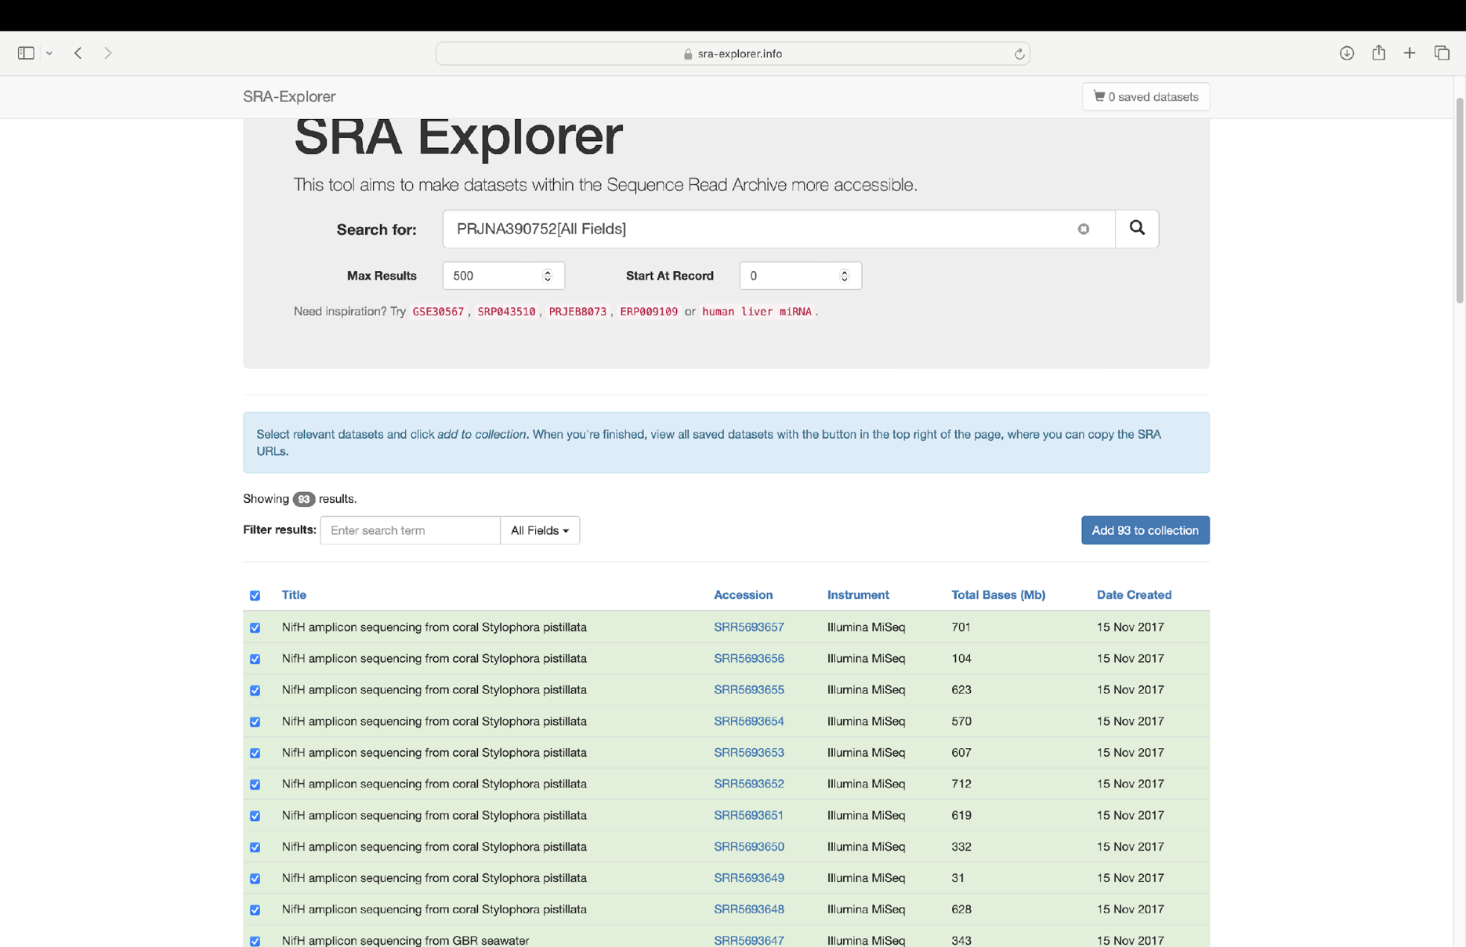



***SRA Explorer: Retrieving FastQ Download Code/Command***

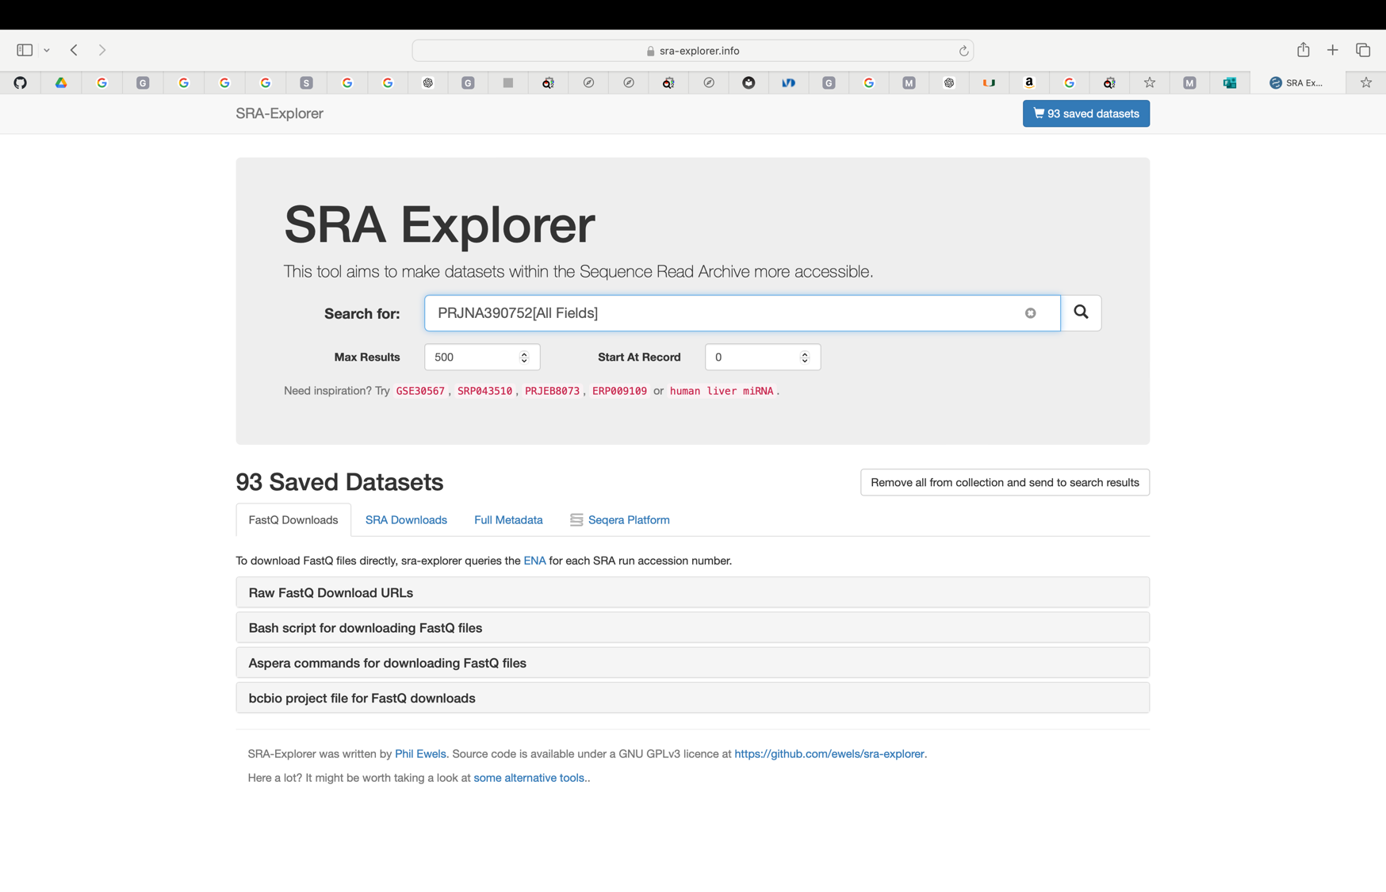The cart webpage will show the amount of datasets saved and tabs to download FastQ, SRA, Metadata, and for Seqera Platform.

This tutorial focuses primarily on FastQ files batch download for Python language. Therefore, select the Fastq Download tab, then select “Bash Script for Downloading Fast Q Files”.

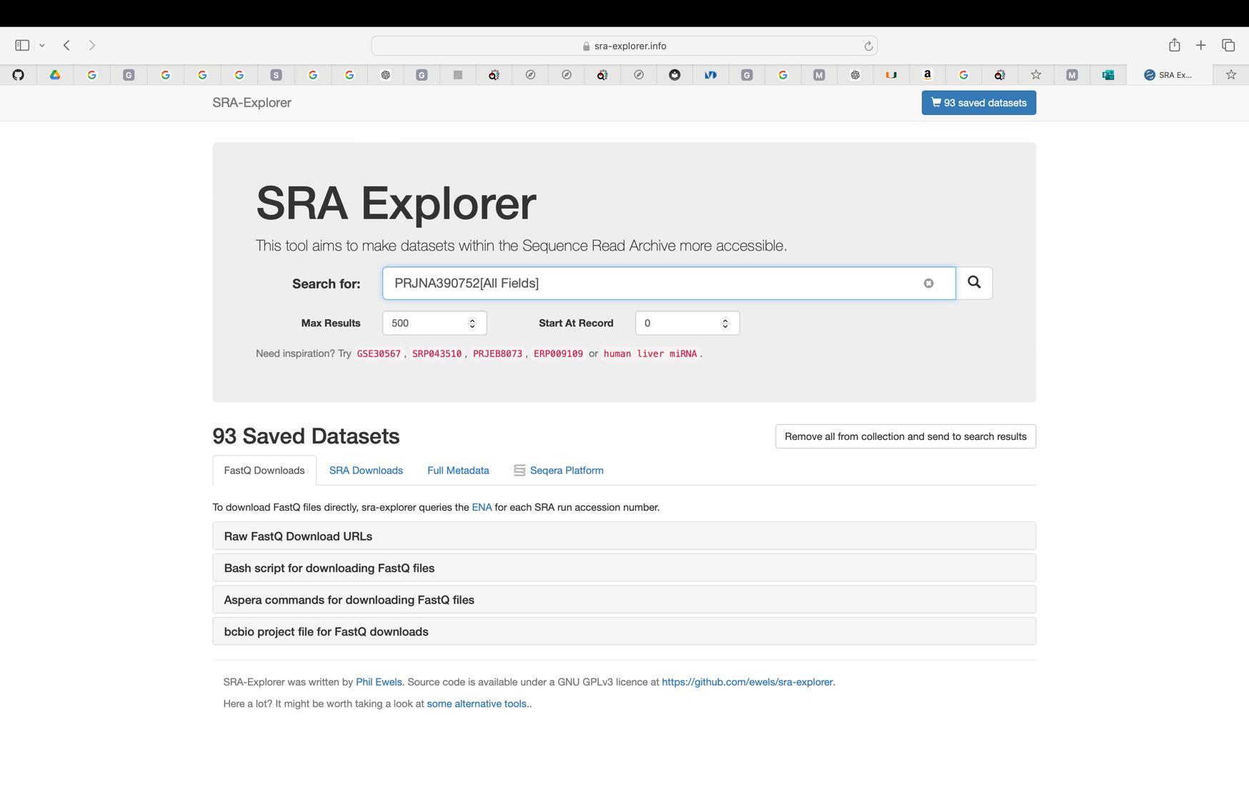



After selecting “Bash Script for Downloading Fast Q Files,” a list of “~curl” commands for all datasets will populate.

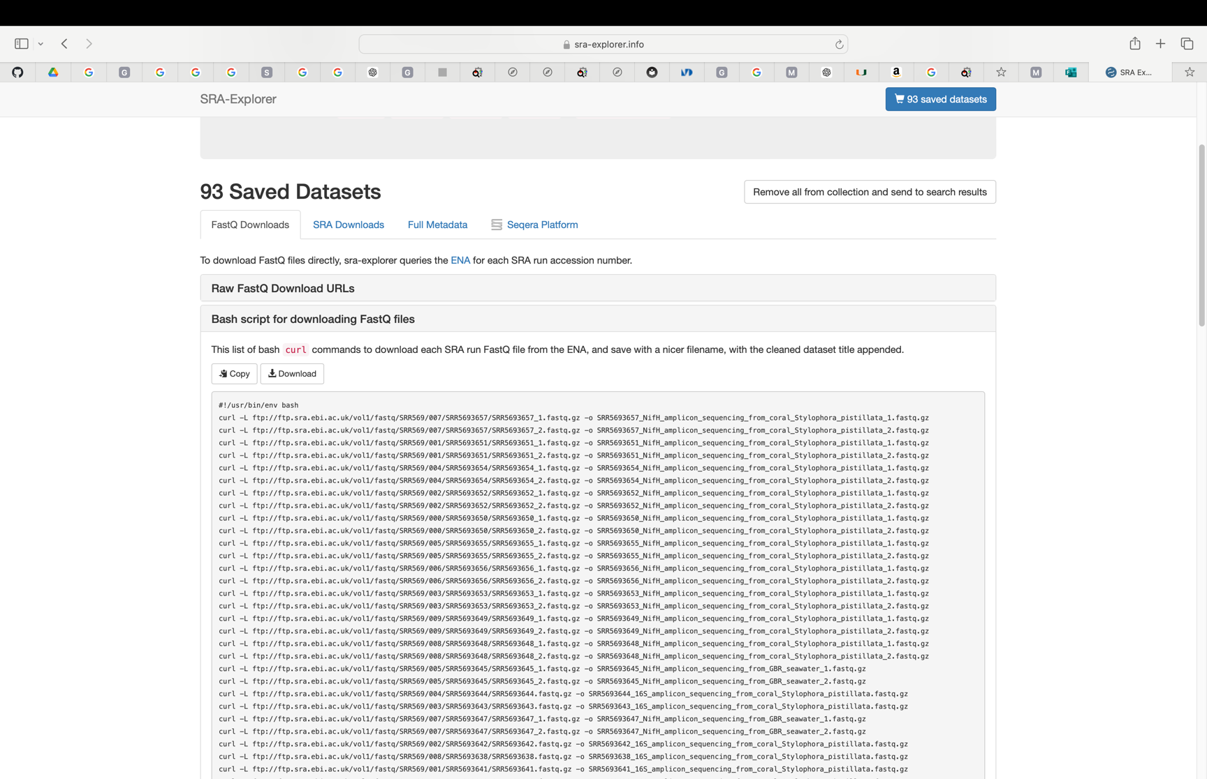Select the “Copy” button to copy the commands and place in a separate text editor, notes, or word document to add to the command/code provide at the bottom of this guide.



Script for Batch Downloading of FastQ Files:

#!/usr/bin/env bash

# Array of URLs to download

Urls=(

Place ~curl list of fastq files copied from SRA-Explorer Here

)

# Base directory to save files

base_dir="/Place path of the folder where the files will be saved here"

# Loop through each URL and download the file

for url in "${urls[@]}"; do

filename=$(basename "$url") # Extract filename from URL

output_path="$base_dir/$filename" # Construct output path

# Download file and save it

echo "Downloading $filename..."

curl -L "$url" -o "$output_path"

# Check if download was successful

if [ $? -eq 0 ]; then

echo "Downloaded $filename successfully."

else

echo "Failed to download $filename."

fi

done

Example:

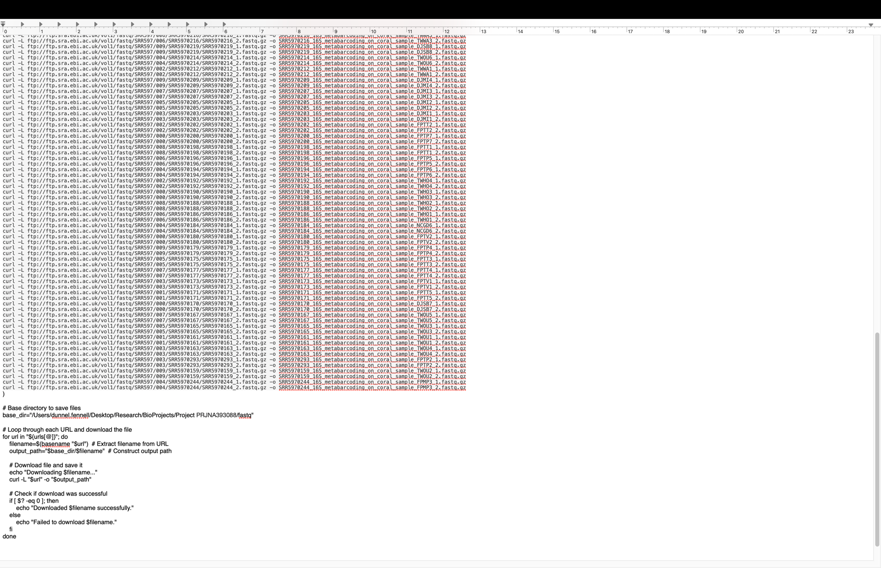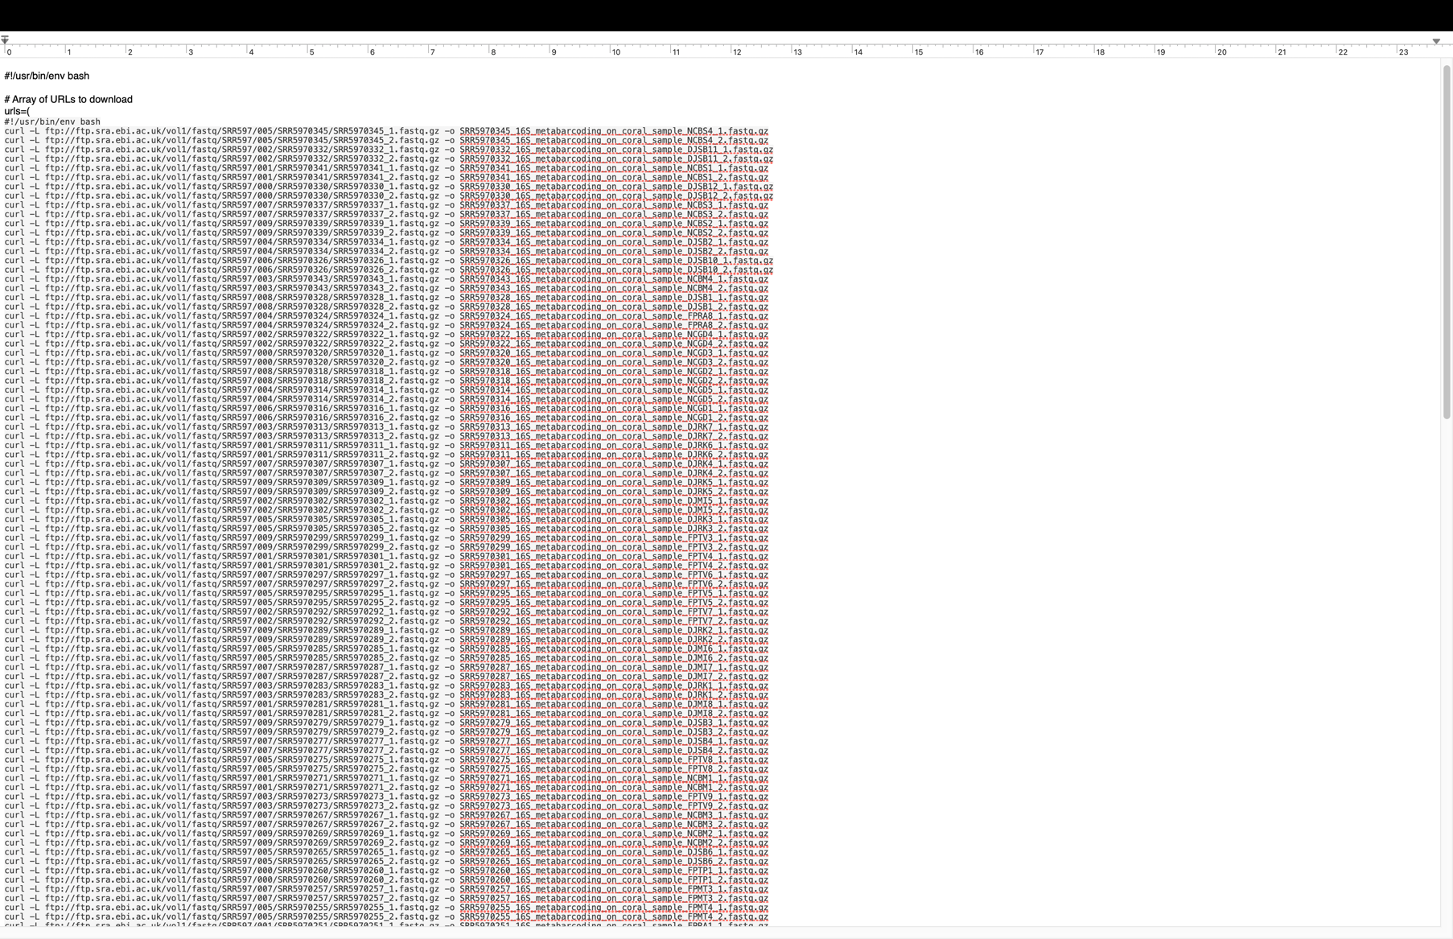This is how the command/code needs to be written the “Bash Script for Downloading Fast Q Files” ~curl script is place into code, along with the pathname for the folder where the files will be saved.

Copy and paste the edited version in to terminal and press enter to begin downloading.